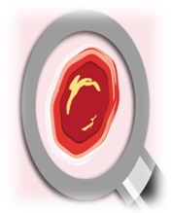
What to expect
- 2.5 hour programme
- Led by Clinical Nurse Specialist and Specialist Rehabilitation Engineer from PUPIS service
- Practical and interactive - non-medical aspects of pressure ulcer care
- Aimed at front-line staff (support workers, nurses, therapists) and care managers
- Certificates and pack provided

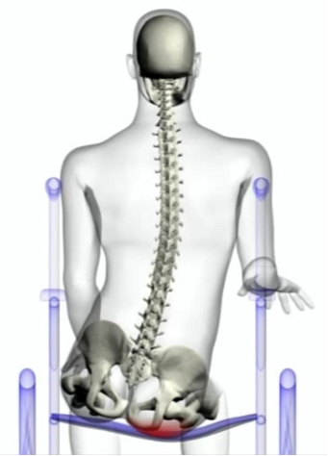
Training includes
- Pressure Ulcer basics
- Identifying risks
- Problem solving
- Equipment
  - importance of surface, shape and set-up
  - hands-on with pressure relieving equipment
- Posture and Positioning
- Interface pressure mapping - exploring key offloading principles
- Case studies
- Open discussions and opportunity to consider your own cases
- Network with other staff and understand the role we all have in pressure ulcer care
- Options for support (including PUPIS referral process)
- Live demonstrations
- Tour of department

The session is free to attend but there are limited places (max 24 per session) - email ABM.PUPIS@wales.nhs.uk to register interest as the demand for this training programme is high

Background
PUPIS has been serving the local community in and around ABMU Health Board for 15 year, assessing in excess of 3000 people with pressure ulcers, plus providing information, advice and solutions affecting many more. PUPIS relies strongly on a collaborative approach, both within the team and with others. The PUPIS team will be sharing a practical, patient-centred and holistic approach to pressure risk. The programme focuses on increasing preventative awareness of pressure risk, up-skilling caring staff to act appropriately in response to identified risk, guiding staff towards solutions, and exploring options for support.

